Creating Layouts
We learnt to float our divs to get the desired layout for our superhero page. If you note closely, the section containing these divs is not balanced. The right floating div is floating to the extreme right of our page. Ideally, both the divs should have occupied 50% space of the entire page.

If you remember, when we floated the multiple divs to left they were aligned next to each other.
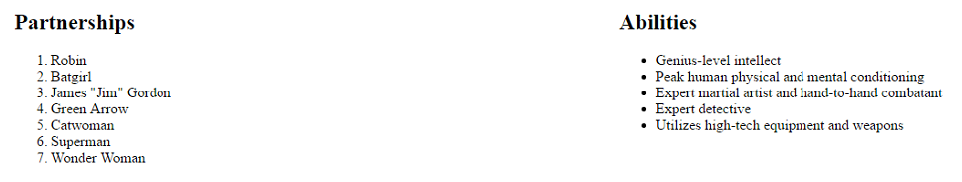
We could assign 50% of space to each div and float both of them to left to get a balanced layout. We also learnt that divs are used to create sections in your web page. As a good coding practice, we should create a div which will have both these divs. It will also help us style both these divs.
Follow following steps to get this desired outcome.

1. Create a new class named box in the stylesheet. We will assign this box class to both the divs. The box class will have the following styling
.box{
display: inline-block;
width: 50%;
float:left;
}
We have discussed these style properties earlier.

Assign box class to both the divs. We will replace existing class (<div class="left"> and <div class=”right”>) by <div class="box">
2. Create a new div which will contain both these divs. Assign list_box class to this section. Go to stylesheet and write following style stament for this div.

.list_box{
width:100%;
overflow:hidden;
}

In HTML document create new div (with class = list _box) and include both our lists in this new div. The code structure will look like this
<div class=list_box>
<div class=box>
Include your left content for your ordered list
</div>
<div class=box>
Include your left content for your unordered list
</div>
</div>
By following these steps you will be able to create a better-looking layout for our lists. You should include this structure in your superhero HTML page.

